**PATUAKHALI SCIENCE AND TECHNOLOGY UNIVERSITY**

Course Code: C

IT

-

11

2



**SUBMITTED TO:**

Prof. MD Mahbubur Rahman Sir

**Department of Computer Science And Communication**

**Engineering**

**Faculty of Computer Science And Engineering**

**SUBMITTED BY:**

Name: MD Noushad Bhuiyan

ID: 2102038, Registration No: 10165

Faculty of Computer Science and Engineering

**Date of submission: 4-15-2023**

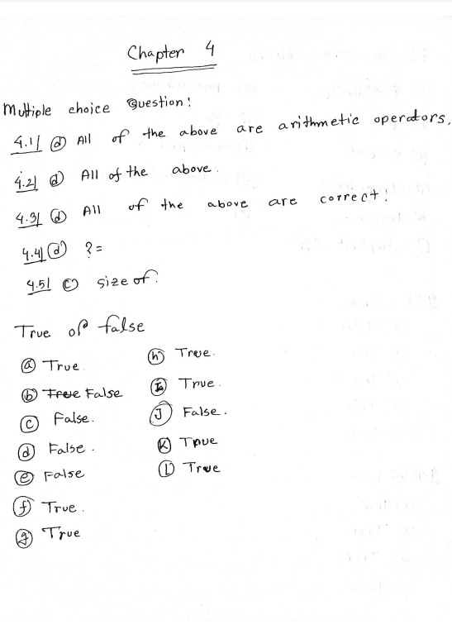

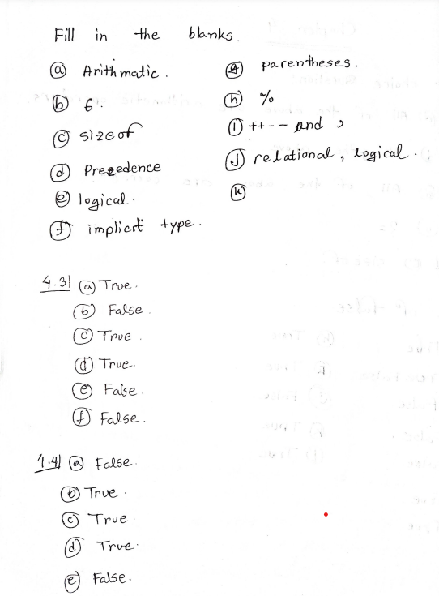

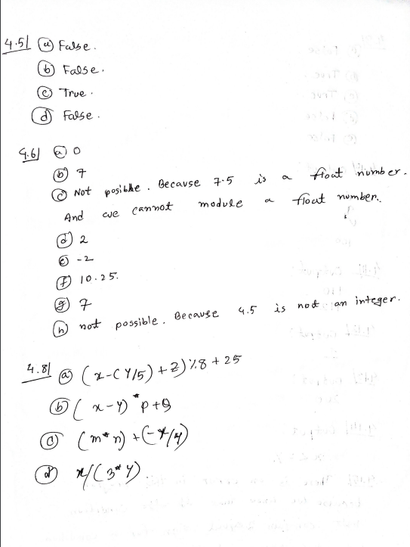

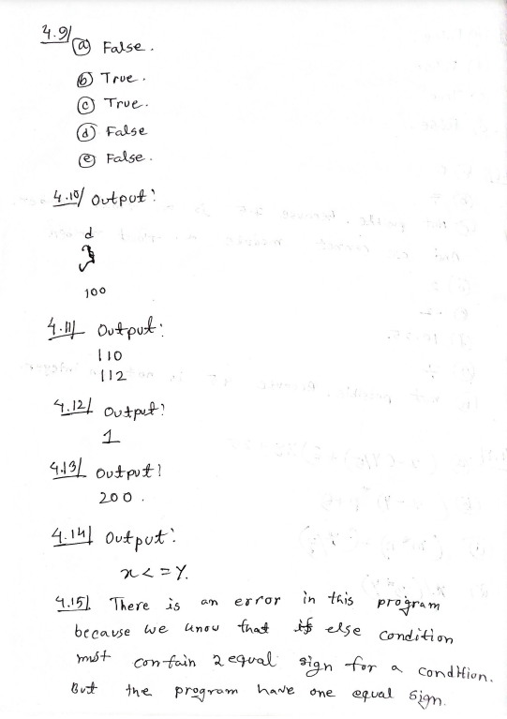

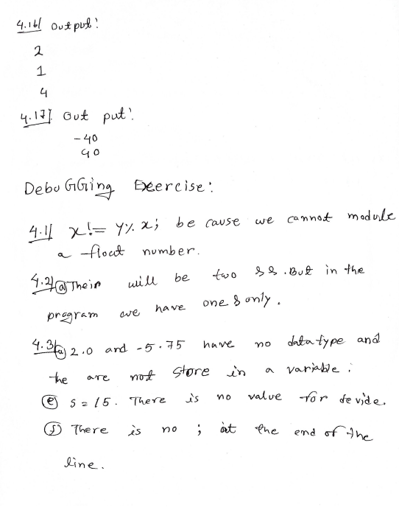

**Programming exercise**

4.1 A program displays the right-most digit of the integral part of the number

#include<stdio.h>

int main()

{

int a,e;

printf("Enter the value of a\n");

scanf("%d",&a);

e=a%10;

if(a>10)

printf("%d\n%d\n",a,e);

}

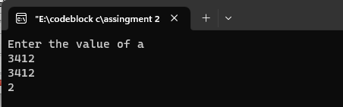

4.2 Modify the above program to display the two rightmost digits of the integral part

#include<stdio.h>

int main()

{

int a,e;

printf("Enter the value of a\n");

scanf("%d",&a);

e=a%100;

if(a>100)

printf("%d\n%d\n",a,e);

}

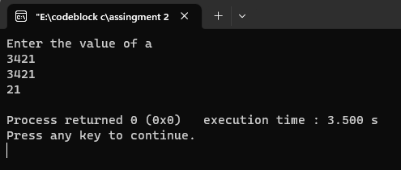

4.3 Given an integer number, write a program that displays the number as follows: First line : all digits Second line : all except first digit Third line : all except first two digits

#include<stdio.h>

int main()

{

int n,i,x;

printf("Enter the number: ");

scanf("%d",&n);

for(i=n;i>=1;i--)

{

for(x=1;x<=i;x++)

{

printf("%d ",x);

}

printf("\n");

}

}

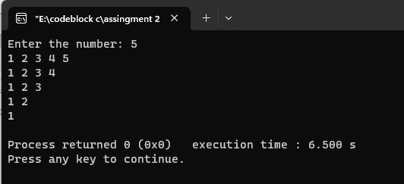

4.4 a program to determine the salvage value of an item when the purchase price, years of service, and the annual depreciation are given

#include<stdio.h>

int main()

{

//pp= purchase price;sv=salvage value;yos=years of service;

//dep=Depreciation

float pp,sv,yos;

float dep

printf("Enter Purchase Price: ");

scanf("%f",&pp);

printf("Enter Depreciation: ");

scanf("%f",&dep);

printf("Enter Years of service: ");

scanf("%f",&yos);

sv=pp-(yos*dep);

printf("Salvage value = %0.2f",sv);

}

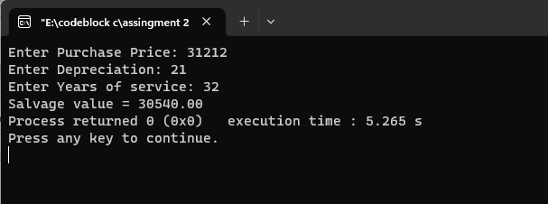

4.6 The total distance travelled by a vehicle in t seconds

#include<stdio.h>

int main()

{

//a=acceleration;t=time;u=initial velocity;d=distance;

float d,t,a,u;

printf("Enter Initial velocity: ");

scanf("%f",&u);

printf("Enter Acceleration: ");

scanf("%f",&a);

printf("Enter time: ");

scanf("%f",&t);

d=(u*t+(a*t*t)/2);

printf("The distance is : %0.3f",d);

}

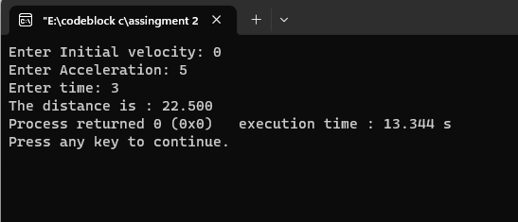

4.7 a program to compute EOQ and TBO, given demand rate (items per unit time), setup costs (per order), and the holding cost (per item per unit time).

#include<stdio.h>

int main()

/*

demand rate=dr ;setup cost = sc ;holding cost per item per unit time = hc ;

*/

{

float TBO,EOQ,dr,sc,hc;

printf("Enter demand rate: ");

scanf("%f",&dr);

printf("Enter setup cost: ");

scanf("%f",&sc);

printf("Enter holding cost per item per unit time: ");

scanf("%f",&hc);

EOQ = sqrt((2*dr*sc)/(hc));

TBO = sqrt((2*sc)/(dr*hc));

printf("TBO is : %0.3f\n",TBO);

printf("EOQ is : %0.3f\n",EOQ);

}

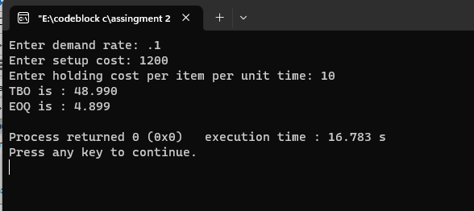

4.8 a program to calculate the frequency for different values of C starting from 0.01 to 0.1 in steps of 0.01.

#include<stdio.h>

int main()

{

double r,c,l,fr;

//r=resistance;l=inductance;c=capacitance;fr=frequency;

printf("Enter resistance: ");

scanf("%lf",&r);

printf("Enter inductance: ");

scanf("%lf",&l);

printf("Enter capacitance from 0.01 to 0.1: ");

scanf("%lf",&c);

fr=sqrt((1/(l*c))-((r*r)/(4*c*c)));

printf("The Frequency is %0.2lf",fr);

}

4.9 a program to read a four digit integer and print the sum of its digits

#include<stdio.h>

int main()

{

int n,sum=0,r,x;

printf("Enter a number of four digits: ");

scanf("%d",&n);

while(n!=0){

r=n%10;

sum=sum+r;

n=n/10;}

printf("Sum of digits are : %d",sum);

}

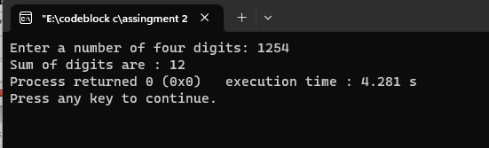

4.10 a program to read three values from keyboard and print out the largest of them without using if statement.

#include<stdio.h>

int main()

{

int n1,n2,n3;

printf("Enter 1st number: \n");

scanf("%d",&n1);

printf("Enter 2nd number: \n");

scanf("%d",&n2);

printf("Enter 3rd number: \n");

scanf("%d",&n3);

int maximum = (n1> n2) ? ((n1 > n3) ? n1 : n3) : ((n2 > n3) ? n2 : n3);

printf("Maximum value is : %d",maximum);

}

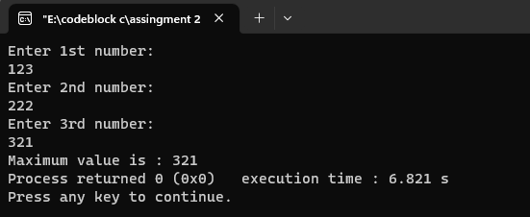

4.11 a program to read two integer values m and n and to decide and print whether m is a multiple of n.

#include<stdio.h>

int main()

{

int m,n;

printf("Enter a number(n): ");

scanf("%d",&n);

m=n*n;

printf("The value of n is %d\n",n);

printf("The value of m is %d\n",m);

}

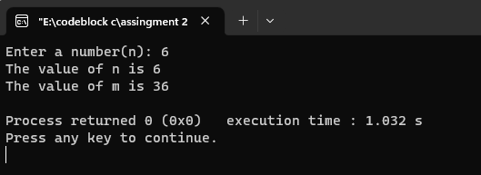

4.12 a program to read three values using scanf statement and print the following results: (a) Sum of the values (b) Average of the three values (c) Largest of the three (d) Smallest of the three

#include<stdio.h>

int main()

{

int n1,n2,n3;

printf("Enter 1st number: \n");

scanf("%d",&n1);

printf("Enter 2nd number: \n");

scanf("%d",&n2);

printf("Enter 3rd number: \n");

scanf("%d",&n3);

if(n1>n2&&n1>n3)

printf("%d is large number. \n",n1);

else if(n2>n1&&n2>n3)

printf("%d is large number. \n",n2);

else

printf("%d is large number. \n",n3);

printf("\n\n");

if(n1<n2&&n1<n3)

printf("%d is small number. \n",n1);

else if(n2<n1&&n2<n3)

printf("%d is small number. \n",n2);

else

printf("%d is small number. \n",n3);

printf("\n\n");

int sum=n1+n2+n3;

float av= sum/3;

printf("The sum of three digits are: %d\n\n",sum);

printf("The average of three digits are: %f\n\n",av);

}

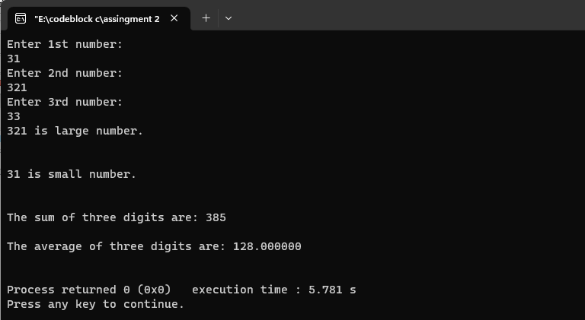

4.14 a program to print a table of sin and cos functions for the interval from 0 to 180 degrees in increments of 15

#include<stdio.h>

#include<math.h>

int main()

{

float x,y,i;

printf("Angle sin(Angle) cos(Angle)\n");

for(i=0;i<=180;i=i+15)

{

x=sin(i);

y=cos(i);

printf("%0.2f %0.2f %0.2f\n",i,x,y);

}

}

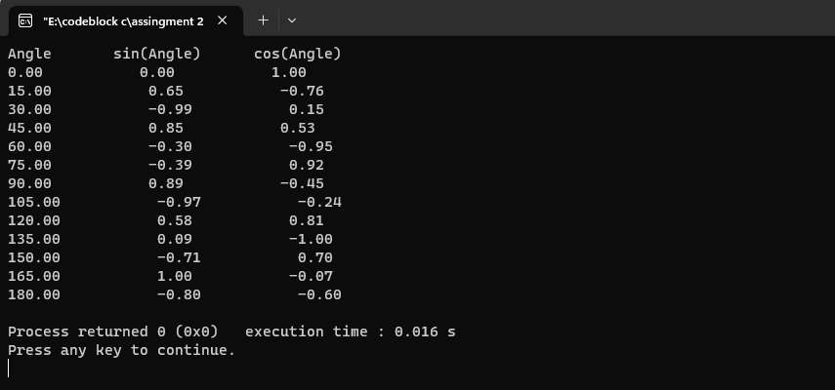

4.15 a program to compute the values of squareroots and squares of the numbers 0 to 100 in steps 10 and print the output in a tabular form

#include<stdio.h>

int main()

{

float i,x,y;

printf("Value square squareroot\n");

for(i=0;i<=100;i=i+10)

{

x=i*i;

y=sqrt(i);

printf("%0.2f %0.2f %0.2f\n",i,x,y);

}

}

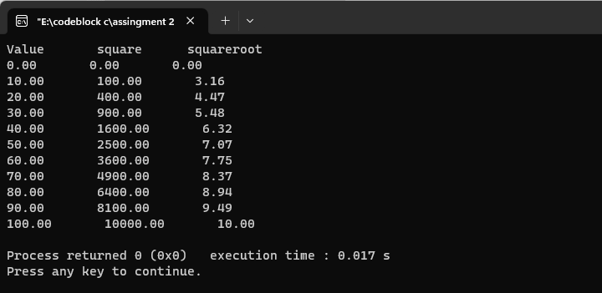

4.17 a C program to shift the given data by two bits to the left.

#include<stdio.h>

int main(){

int d =5;

printf("%d",(d<<2));

}

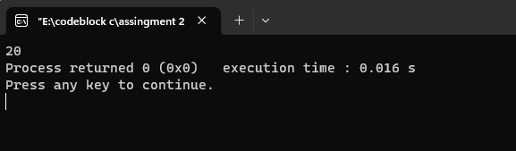

4.18 a C program to compute the value of the expression x=a-b/3+c*2-1.

#include<stdio.h>

int main()

{

float a,b,c,x;

printf("Enter a: ");

scanf("%f",&a);

printf("Enter b: ");

scanf("%f",&b);

printf("Enter c: ");

scanf("%f",&c);

x=a-b/3+c*2-1;

printf("The value of x is = %0.2f",x);

}

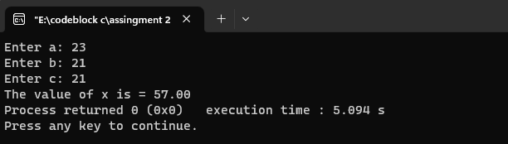

4.20 a C program to input a date value and determine whether the entered day, month, and year values are valid.

#include<stdio.h>

int main()

{

int year,t,rd,rd2,month,week,days;

printf("Enter days numbers: ");

scanf("%d",&t);

//rh=remain second after getting hours

year=t/365;

rd=t%365;

month=rd/30;

rd2=rd%30;

week=rd2/7;

days=rd2%7;

printf("Days are %d years, %d months, %d weeks, %d days",year,month,week,days);

return 0;

}

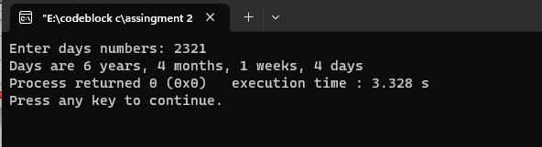

4.20 a C program to input the sides of a triangle and determine whether the triangle is isoceles or not.

#include <stdio.h>

int main() {

int side1, side2, side3;

// Read the lengths of three sides of the triangle

printf("Enter the lengths of three sides of the triangle: ");

scanf("%d %d %d", &side1, &side2, &side3);

// Check if the triangle is isosceles or not

if (side1 == side2 || side1 == side3 || side2 == side3) {

printf("The triangle is isosceles.");

} else {

printf("The triangle is not isosceles.");

}

return 0;

}

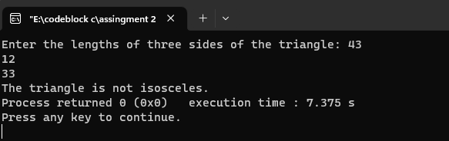

4.21 a C program that reads two numbers and performs their division. If the division is not possible, then an error message, ‘Division not possible’ is displayed.

#include<stdio.h>

int main()

{

float x,y,z;

printf("Enter 1st value: ");

scanf("%f",&x);

printf("Enter 2nd value: ");

scanf("%f",&y);

z=x/y;

if(y==0)

printf("division not possible");

else

printf("The division value is : %0.2f",z);

}

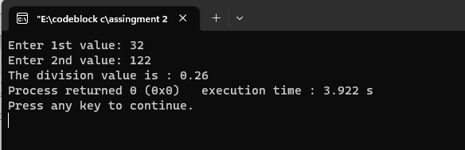

4.22 the value of 4 variables a, b, c and d and compute the resultant value of following expressions: (a + b) * (c / d) (a + b) * c / d a + (b * c) / d

#include<stdio.h>

int main()

{

float x,y,z,a,b,c,d;

printf("Enter a: ");

scanf("%f",&a);

printf("Enter b: ");

scanf("%f",&b);

printf("Enter c: ");

scanf("%f",&c);

printf("Enter d: ");

scanf("%f",&d);

x=(a+b)*(c/d);

y=(a+b)*c/d;

z=a+(b*c)/d;

printf("The 1st value is: %0.2f\n",x);

printf("The 2nd value is: %0.2f\n",y);

printf("The 3rd value is: %0.2f\n",z);

}

